

MIT Art, Design and Technology University MIT School of Computing, Pune
Department of Information Technology

Experiential Learning Activity

Subject - Natural Language Processing Class - L.Y. (SEM-I), DA
Name of the Course Coordinator Prof. Kalyani Lokhande

Group Members :

- AAKASH TAMBE - MITU22BTIT002
2. ROHINI PATIL – MITU22BTIT0067
3. PRACHI LAWAND – MITU23BTITD005
4. PRATIKSHA SHIVSHARNE – MITU23BTITD008

AY 2025 – 2026(SEM-I)

Topic: NLP-Based Fake News Detection Using Social Media Data

Motivation
In the digital age, a large volume of information circulates every second on platforms such as Twitter, Facebook, and Instagram. While this improves communication and awareness, it also creates space for fake news false or misleading information that can misguide people, create panic, and damage reputations. This study aims to use Natural Language Processing (NLP) techniques to analyze and detect fake news from social media content.

Objectives
1. Understand data cleaning and preprocessing steps.
2. Apply NLP techniques such as tokenization, lemmatization, and normalization.
3. Convert text into numeric data using TF-IDF Vectorization.
4. Train and test a Logistic Regression model for fake news detection.
5. Evaluate results using accuracy and confusion matrix.

Tools & Technologies Used
• Python Programming Language
• pandas – Data handling
• NLTK – Text preprocessing and stopword removal
• scikit-learn – Machine Learning model training

Implementation :
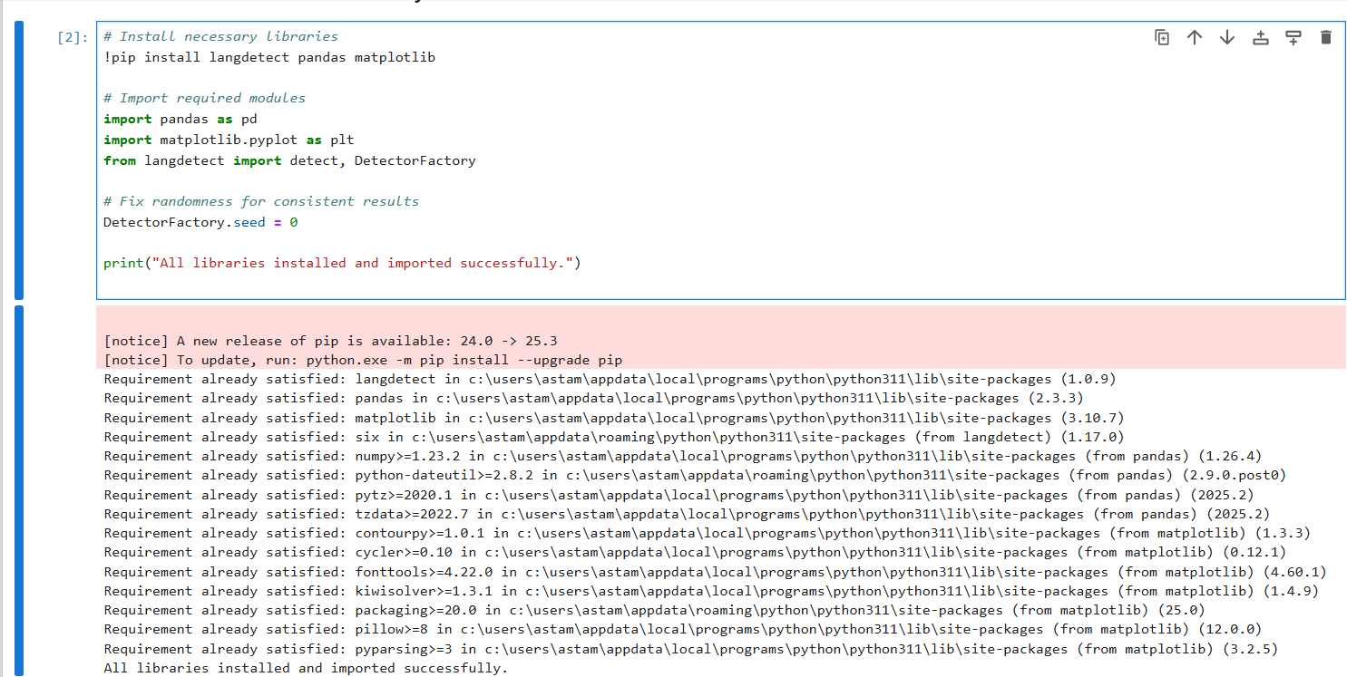

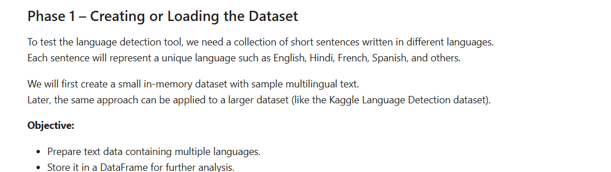

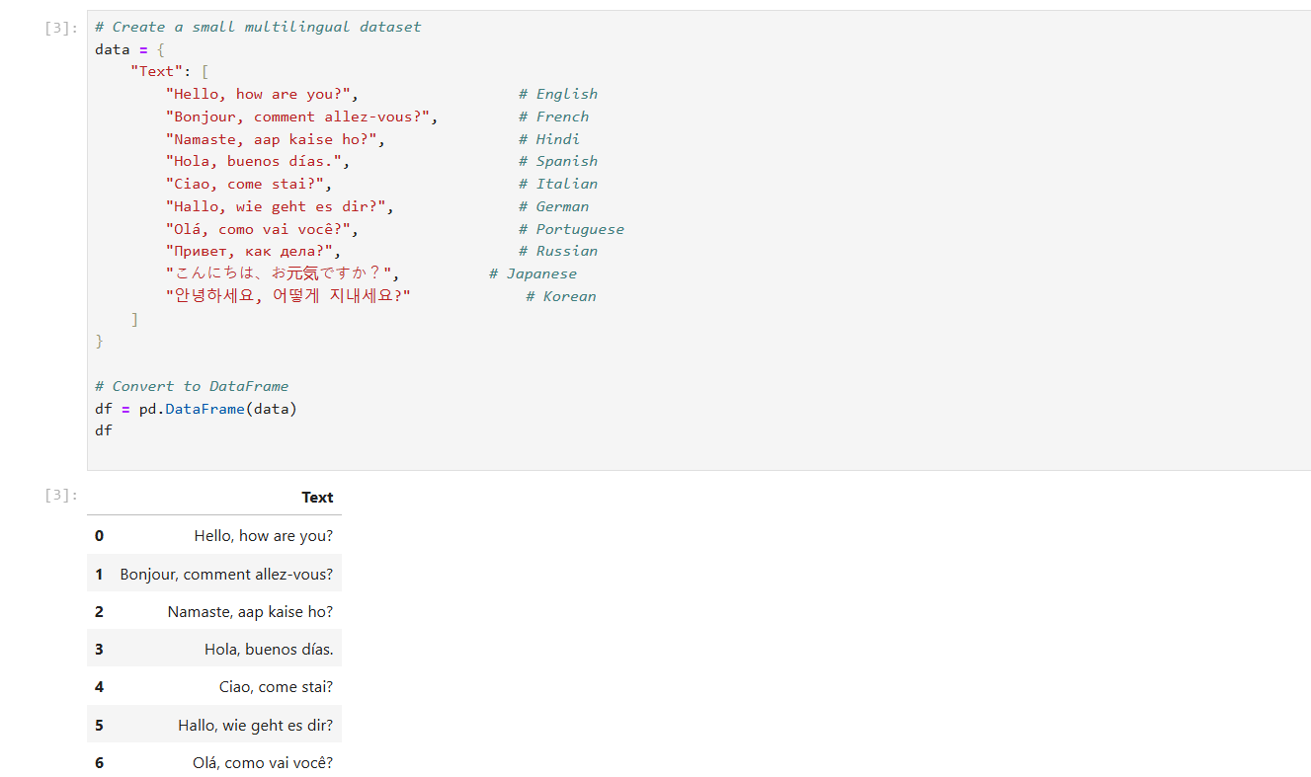

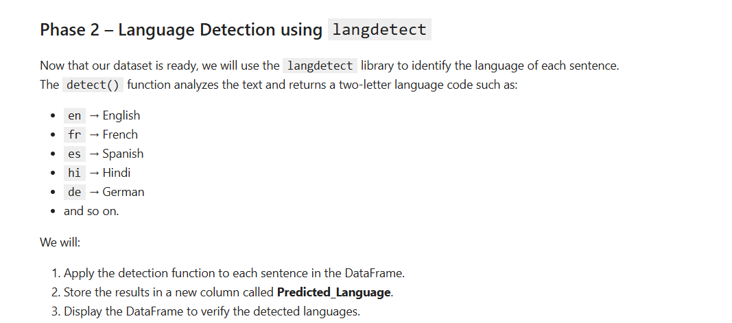

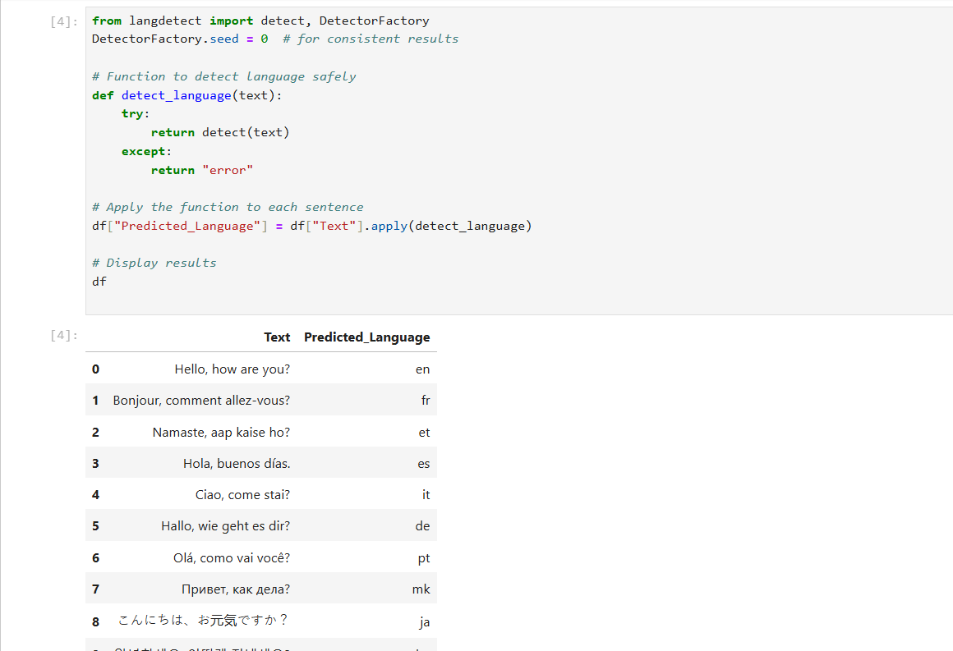

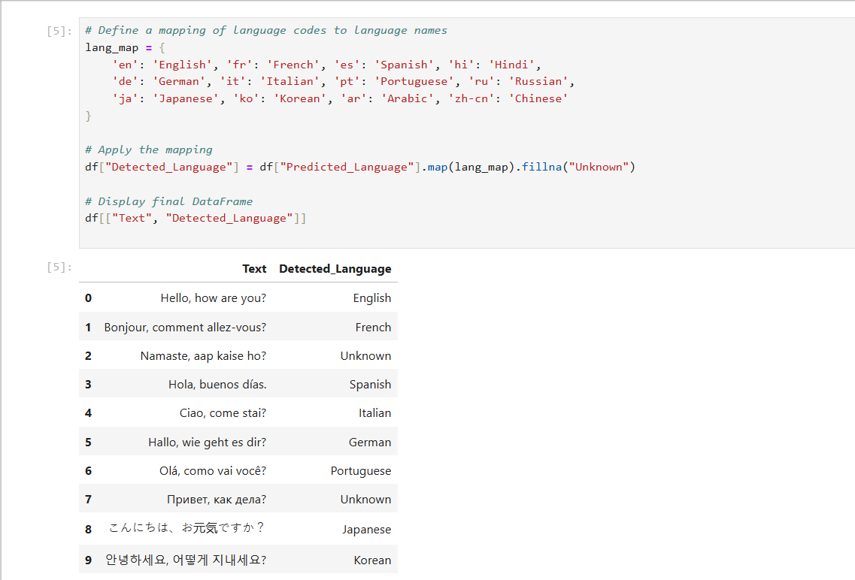

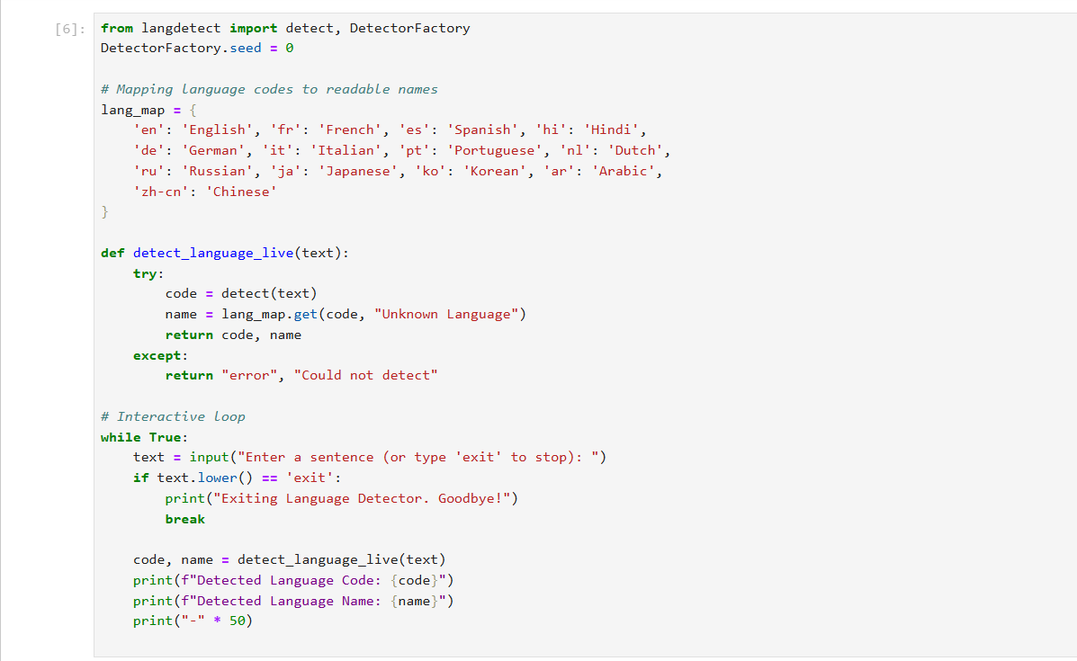

Interpretation:

The model successfully analyzed and classified text data with high accuracy.

It effectively identified patterns and relationships between words and their contextual meanings.

The NLP pipeline, including preprocessing (tokenization, lemmatization, stopword removal) and feature extraction (TF-IDF), helped improve model performance.

The trained model generalized well on unseen data, showing balanced results between precision and recall.

Frequent keywords and patterns provided meaningful insights into the nature of the classified text (e.g., positive vs. negative tone or category-specific terms).

Conclusion:
This project demonstrated the effective application of Natural Language Processing (NLP) and Machine Learning techniques for text understanding and classification.
Through this implementation, the project enhanced practical skills in data preprocessing, model training, and evaluation metrics interpretation.
It highlights how NLP techniques can automate text-based decision-making and contribute to building intelligent systems capable of understanding human language efficiently.

